 | Communication, Dissemination and Exploitation Plan
 | Deliverable ID: | D4.1
 | Project Acronym: | F4EClim
 | Grant: | 101167020
 | Call: | HORIZON-SESAR-2023-DES-ER-02
 | Topic: | ATM Excellent science and outreach for the aviation Green Deal
 | Consortium Coordinator: | DLR
 | Edition date: | 06 November 2024
 | Edition: | 00.03
 | Status: | Draft
 | Classification: | [PU]


Abstract
The present deliverable details the communication, dissemination, and exploitation plan of the F4EClim project. The deliverable includes 4 high-level messages and a short description to be broadcasted in different media with the aim at making the project understandable at a first glance. It states the communication and dissemination goals, which have been disaggregated by target audiences. The deliverable describes the intended communication, dissemination, and exploitation strategy to reach the established goals. This strategy includes the communication, and dissemination means (including the project’s website, the social media, targeted conferences and scientific journals), the open-access strategy (including software management strategy), and the strategy to engage different stakeholders. Finally, a detailed communication and dissemination plan of activities is presented, including a schedule and metrics to measure its impact and effectiveness.

Authoring & Approval
Author(s) of the document
Organisation name | Date
TU Delft | 24/10/2024

Reviewed by
Organisation name |  | Date
Virginia Villaplana (UC3M) |  | 05/11/2024

Approved for submission to the SESAR 3 JU by
Organisation name | Date

Rejected by
Organisation name |  |  |  | Date
Document History
Edition | Date | Status | Company Author |  | Justification
00.01 | 16/10/2024 | Draft | TU Delft |  | New document
00.02 | 24/10/2024 | Draft | TU Delft |  | First draft
00.03 | 05/11/2024 | Draft | UC3M |  | Second draft

Copyright Statement
© 2024 – F4EClim Consortium. All rights reserved. Licensed to SESAR 3 Joint Undertaking under conditions.

F4EClim
FLYING atm FOR ENVIORNMENTAL CLIMATE


This document is part of a project that has received funding from the SESAR 3 Joint Undertaking under grant agreement No 101167020 under European Union’s Horizon Europe research and innovation programme.


Table of Contents

Abstract 1
1 Introduction 7
1.1 Definitions 7
1.2 Applicable reference material 7
2 Project introduction 8
2.1 About F4EClim 8
2.2 Key messages of F4EClim 8
2.3 Keywords 9
2.4 Focal point for communications, dissemination and exploitation. 9
2.5 Stakeholders identification 9
3 Communication 11
3.1 Communications objectives and strategy 11
3.2 Communication target audiences 11
3.3 Branding and acknowledgements 11
3.4 Communication channels 12
3.4.1 Website 12
3.4.2 Press and media 13
3.4.3 Social media 13
3.4.4 Communication events 14
3.4.5 Publications and newsletters 14
3.4.6 Videos 15
3.5 Communication key performance indicators (KPIs) and success criteria 15
4 Dissemination 17
4.1 Dissemination objectives and strategy 17
4.2 Dissemination channels 17
4.2.1 Open access to scientific publications 17
4.2.2 Dissemination through open software 18
4.2.3 Dissemination events 18
4.3 Dissemination target audiences 18
4.4 Dissemination KPIs and success criteria 19
5 Exploitation 21
5.1 Project exploitable results 21
5.2 Exploitation strategy and objectives 21
5.3 Exploitation of results 21
5.4 Data protection strategy 22
5.5 IPR management 22
6 Overview of communication and dissemination activities 23
7 List of acronyms 24
8 Guidelines 25
8.1 Indication of funding 25
8.2 Disclaimer excluding SESAR 3 JU responsibility 25

List of Figures

Figure 1: Definitions of communication, dissemination and exploitation in Horizon Europe 6
Figure 2: Project logo 11
Figure 2: Snapshot of the F4EClim website. 11
Figure 3: SJU website of F4EClim. 12
Figure 4: F4ECLIM LinkedIn group. 13
Figure 5: F4ECLIM Twitter profile. 13

List of Tables
Table 1: Focal points of contact 8
Table 2: Stakeholders 9
Table 3: Communications target audiences 10
Table 4: Contribution to external media. 12
Table 5: Events 13
Table 6: Communication KPIs and success criteria 15
Table 7: Dissemination channels 16
Table 8: Scientific papers, publications and presentations 17
Table 9: Dissemination conferences and workshops 17
Table 10: Dissemination target audiences 18
Table 11: Dissemination KPIs and success criteria 19
Table 12: Project internal exploitation of results 20
Table 13: Project external exploitation of results 21
Table 14: Overview of communication and dissemination Activities 22
Table 15: List of acronyms 23
Table 16: F4EClim consortium acronyms. 23

Introduction
The present deliverable details the communication, dissemination and exploitation plan for F4EClim. It details the communication goals, high-level messages and a short description to be broadcasted in different media with the aim of making the project understandable at a first glance.
The communication means include the project’s website, the social media and other relevant means. The deliverable also details the strategy the project will follow to make use of or disseminate the project’s results, as a plan of activities including a schedule and metrics to measure its impact and effectiveness.
The exploitation charter explains the project’s approach and strategy to make the best use of the project results.

Definitions
Before getting started, it is important to note the difference between communications and dissemination - see figure 1. It is important to note that the guidance in this document refers to external communications and not internal communications between project consortium members.
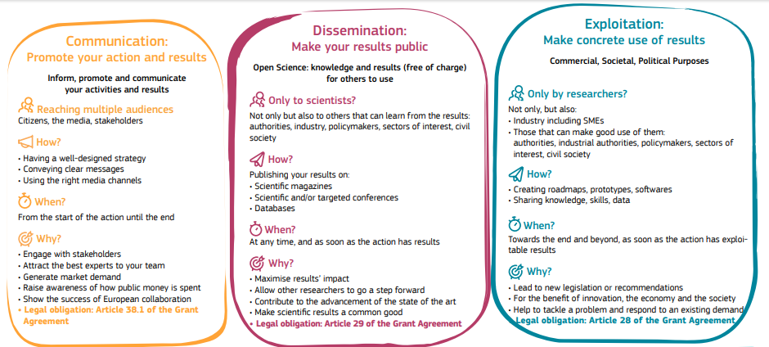
Figure 1: Definitions of communication, dissemination and exploitation in Horizon Europe

Applicable reference material
This plan satisfies the content and activities identified in Section 3.9 of the SESAR 3 Joint Undertaking Project Handbook [1], the article 38.1 of the Grant Agreement concerning the communication activities of the partners, and the instructions provided in the H2020 Communication Guide with regard to the communication strategy [2].

Project introduction

About F4EClim
The following paragraphs summarize the overall objectives of the F4ECLIM project:
“F4EClim’s aims to advance a spatially and temporally resolved MET service on climate effects of aviation, integrating weather forecasts and climate science to address uncertainties tied to non-CO₂ effects, e.g., contrail-cirrus, NO_{x}-induced effects on ozone and methane, and water vapor. This involves evolving the algorithmic Climate Change Functions (aCCFs) to version 2.0, broadening their geographical scope (currently limited to the North Atlantic), considering diverse weather and seasonal patterns, and incorporating various climate metrics. These advancements will feed into a Met service on climate effects for the aviation community. Additionally, F4ECLIM will explore aviation's potential to reduce its climate impact through the development of robust flight planning algorithms. These algorithms will identify eco-efficient aircraft trajectories, assessing the associated climate impact reduction and costs. Hindcast procedures will be employed to scrutinize trajectories and climate models, giving insights in provision of non-CO₂ effects. The project will culminate in recommendations and the introduction of key performance indicators (KPIs) to guide stakeholders in implementing eco-efficient trajectories, reducing uncertainties, and advancing the understanding of the non-CO2 impact of aviation for a greener future.”

Key messages of F4EClim
Aviation accounts for 10% of all transport sector emissions, 2-3% of global CO₂ emissions and 4.9% of all anthropogenic Radiative Forcing (RF)-aviation-induced radiative forcing [, , , ]
F4EClim grasps this need by 1) providing state-of-the-art models that can be used to estimate non-CO₂ climate impact with reflection of potential uncertainties, 2) Exploration of climate impact mitigation potential through operational measures, including robust flight planning to reduce climate effects with a high level of confidence. Three key outcomes are listed in table below.
# Key message id | Communication | Dissemination
#1 Scientific: F4EClim will lead the scientific advances on modelling the climate impact of aviation, in particular the non-CO₂ effects from contrail-cirrus, NO_{x} induced ozone and methane effects, and direct water vapor effect, aiming at enabling mitigatory actions.
#2 Economic: The impact of contrails on flight efficiency, flight time, fuel use, and airspace capacity is yet to be assessed, and is an unmet need. Inaccurate prediction of contrails and navigational avoidance can prove expensive for the airline operators. Therefore, the consortium will respond to this need, and economically benefit by exploiting F4EClim’s results.
#3 Social: F4EClim will contribute to the industry’s efforts to minimize the climatic impact of commercial aviation. By accurately predicting the climate impact of non-CO₂ species, the aviation industry will be able to reduce the climate impact by 20-50% at costs that are relatively small ~1%. This has the potential to significantly improve the operation of air traffic and pave the way towards a more sustainable aeronautics industry.

Keywords
Key Word | Definition
Non-CO₂ climate effects
MET-service
Eco-Efficient flights

Focal point for communications, dissemination and exploitation.
Name | Role | Email address
Dr. Sigrun Matthes | Coordinator/exploitation lead | sigrun.matthes@dlr.de
Dr. Feijia Yin | WP4 lead/Dissimination lead | f.yin@tudelft.nl
VIRGINIA VILLAPLANA FERNANDEZ | Conmmunication lead | vvillapl@pa.uc3m.es
Table 1: Focal points of contact

Stakeholders identification
The CDE activities coordinated by the F4EClim will aim at reaching the following target audiences:
- the scientific community,
- other Stakeholders (aeronautical industry, regulatory community, airlines, etc.) and
- the general public
Impact maximisation of F4EClim is based on a strategic approach for the communication, dissemination, and exploitation of project activities, results, and outcomes. This approach will support the highest possible impact of transitional, intermediary, and outcomes and ensure that benefits are accrued within scientific, regulatory, industrial and societal stakeholder groups. An initial stakeholder portfolio analysis (see Table 2) provides information on the stakeholders. This identifies and prioritises the key stakeholder groups.
Stakeholder | Content
Industry, SMEs, researchers | I.e. science-related information
Project partners
Civil society | i.e. General information on the project

Table 2: Stakeholders

Communication

Communications objectives and strategy
F4EClim communication strategy has been designed to create awareness (on the target audiences identified in Section 3.2) about climatic impact of aviation and potential mitigation strategies under investigation within SESAR ER.
F4EClim will showcase potential climatic impact reductions (and associated costs) derived from achieved results, seeking to foster ATM stakeholder acceptance, and thereby laying the foundations for the future implementation of a climatic-friendly ATM.
This strategy will be Implemented using different media, the definition of a timely plan of communication activities and a series of indicators to measure its impact and effectiveness..

Communication target audiences
Target | Channel | Message | Activities
Regulators |  |  | - Key stakeholder will be invited to form Advisory Board.  - Strategic meetings for two-way communication  - Workshops, symposium, and conferences (face2face &online)  - Web site and social media
OEM
Aligned EU and other projects
European Organisations
Internat. civil aviation bodies
Aircraft operators |  |  | - Invitation to Advisory Board  - Circulate F4ECLIM results  - Utilise interested association bodies, e.g., ACI as dissemination channels
Air Navigation Service Prov.
Airports
National authorities
International structures and interest groups |  |  | - Key stakeholders will be invited to participate on Advisory Board.  - Utilise interested association bodies such as EREA as dissemination channels.  - Conferences, workshops and scholarly outputs to disseminate new knowledge and findings.
EU Interest groups (organ.).
Manufacturing and consulting organisations
Provider of Avionics
Universities/Research Establishments
Specialised media | Website, social media |  | - Website, press release, and newsletter  - Social media, including LinkedIn and X
General media
Consultants
Table 3: Communications target audiences

Branding and acknowledgements
The F4EClim project logo is shown in figure below.
Figure 2: Project logo
Any communication or dissemination of results (in any form, including electronic) will display the SJU logo and the EU emblem, and will include the following text:
“This project has received funding from the SESAR Joint Undertaking under grant agreement No 101167020 under European Union’s Horizon Europe research and innovation programme”.


When displayed together with another logo, the SJU logo and the EU emblem will have appropriate prominence.

Communication channels

Website
A user-friendly website will act as the main information hub, providing an overview of project activities, news, events, public deliverables, publications, etc. It can be found at the domain: www.f4eclim.eu.
In parallel, SJU has developed a specific project web page on the SJU website: https://www.sesarju.eu/projects/F4ECLIM

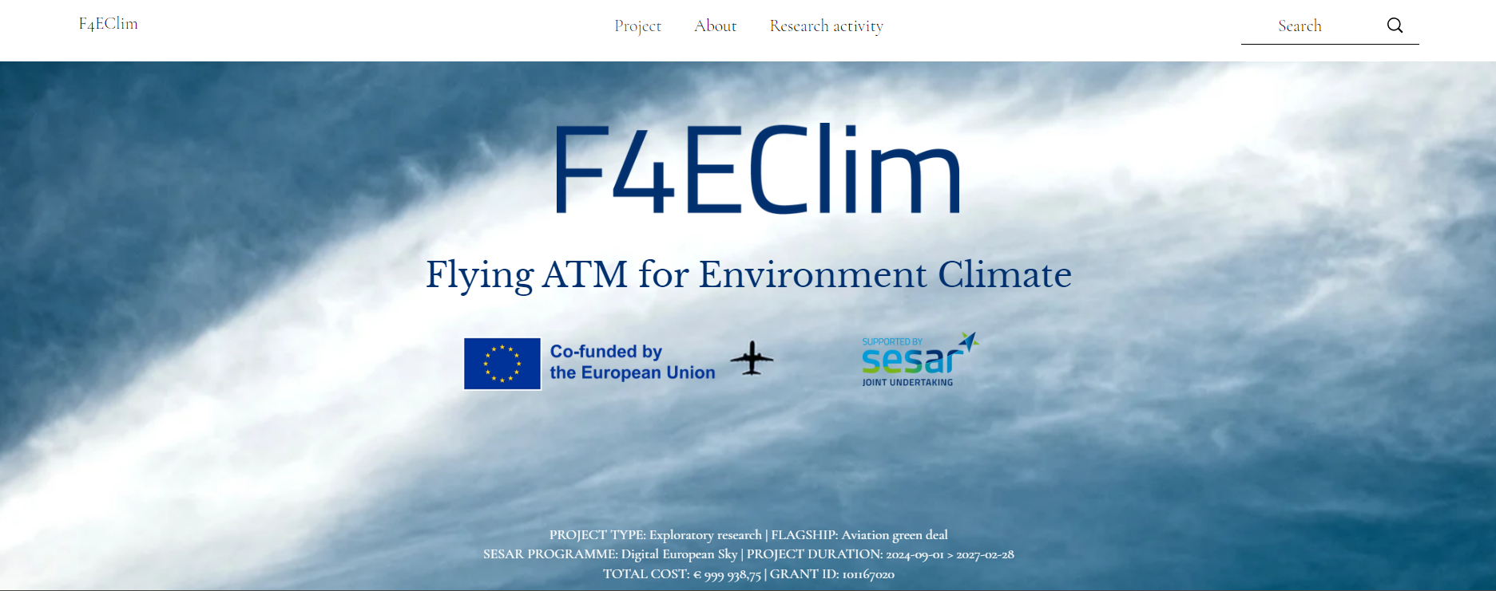
Figure 2: Snapshot of the F4EClim website.
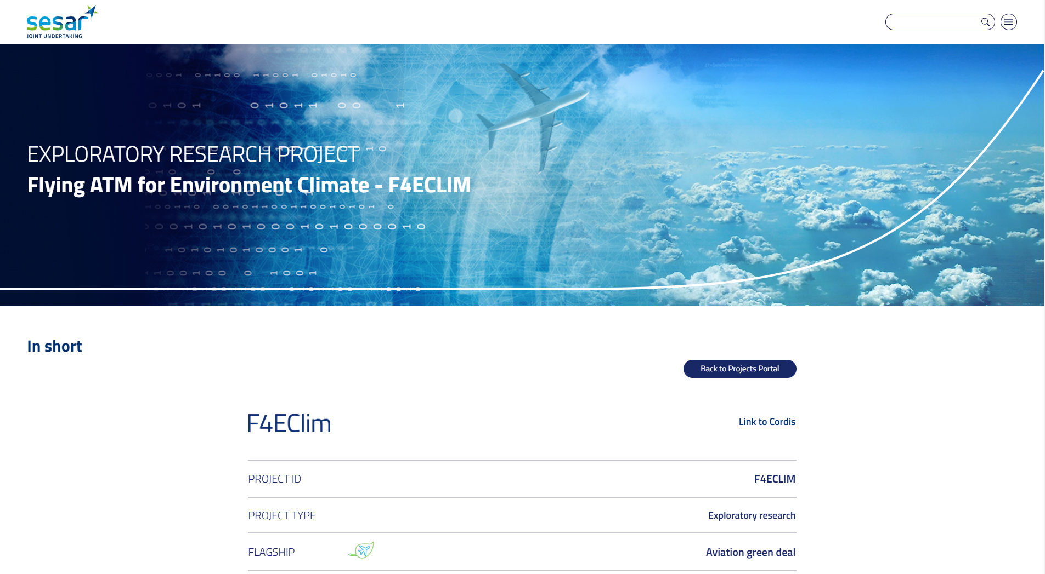
Figure 3: SJU website of F4EClim.

Press and media
Media activity | Date | Link
Past contribution
TV, radio, magazines, journals
Forecasted contribution
TV, radio, magazines, journals
Table 4: Contribution to external media.

Introduce a table with type of media (e.g. press release, news, radio, TV…) with date and link to access.

Social media
F4ECLIM social network profiles will transmit project outputs and engage audience. In particular, the project will be present in the following social media networks:
- LinkedIn, with a page targeted to stakeholders and the scientific community (already on air, see Figure 4).
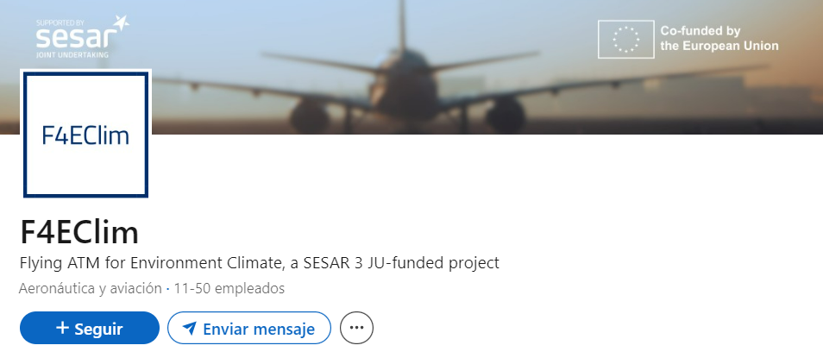
Figure 4: F4ECLIM LinkedIn group.
- Twitter, with a profile targeted to the general public (already on air, see Figure 5).
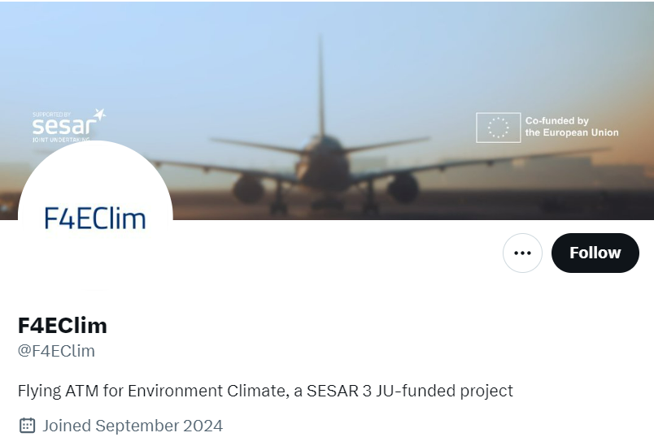
Figure 5: F4ECLIM Twitter profile.

Communication events
Event | Date | Place | Information to be shared | Importance for the project
.
Table 5: Events

Publications and newsletters
Publications/newsletters/printed material | Description | Date | Link
Table 4: Printed material

Videos
Videos | Description | Planning | Link
Table 5: Videos

Communication key performance indicators (KPIs) and success criteria
An overview of the F4ECLIM’s communication activities tailored to the targeted audiences is provided in the table below. The success criteria is set to ensure that the expected KPI valuate will be met by the end of the project. The success of the measures will be monitored during the course of the project and will be updated in the next version of the CDE plan.
Action | KPIs | Success criteria
F4ECLIM public website: A user-friendly website will act as the main information hub, providing an overview of project activities, news, events, public deliverables, publications, etc. | > 1000 visitors  30 news items | Number of visitors to the project website. It can be gathered from free web analytics services as, for example, Google Analytics. It will be reported every six months, showing the evolution of these analytics over the course of the project.
Newsletter: Contribute to SESAR newsletters | 4 news items | Number of news items
Flyers and communications materials: To provide information about the project and project goals in suitable formats | 2 flyers/posters  4 videos | Number of flyers, posters and videos.
Policy briefs: Key information and recommendations for policy makers to influence policy and regulatory actions. | 2 policy briefs | Number of policy briefs.
Social media outreach and communication campaigns: F4ECLIM social network profiles (e.g., Twitter, LinkedIn, YouTube) will transmit project outputs and engage audience. | >100 followers per social network  50 posts (per year and social network)  5 average engagements/post  > 2000 total visualizations of videos | X: Number of twits, number of re-twits, number of “followers” and “following”; click-throughs with benchmark. It will be reported every six months, showing the evolution of these analytics over the course of the project  Linked-in: Number of messages, number of “followers” and “following”. It will be reported every six months, showing the evolution of these analytics over the course of the project.
Participation in events (conferences, workshops, site-visits, etc.) Partners will participate in relevant events where activities and results can be widely showcased, stakeholder ca be engaged, and exchanges established with relevant initiatives. | > 5 events and 1 webinar  > 30 attendees from +5 nationalities | Number of attendants to the workshop, including speakers and panellists. We will measure the nationalities and the stakeholders
Partner channels: Access to partners’ existing communication channels such as their websites, social networks accounts, etc. | > 10 referrals in external websites  30 overall mentions in social media | Number of referrals and mentions
Influencer channels: Identify and raise awareness about the project among European leaders that play an influential role in the environmental field by participating in their conversations | 2 engagement responses from influential ENV channels | Targeted engagement responses
Table 6: Communication KPIs and success criteria

Dissemination

Dissemination objectives and strategy
In order to enhance excellence in science, F4EClim has a commitment to deliver state-of-the-art research, attending scientific conferences with international peer review and proceedings publication, yet to publish in top ranked JCR journals and also publish according to the open access philosophy (direct cost has been allocated to GOLD open Access publications). Other activities oriented towards the dissemination of research results include: the elaboration of the project web site and the organization of a workshop, as well as fostering high-talented individuals to follow scientific careers.

Dissemination channels
Channel | Objective | Tools | Link | Information to be shared
Scientific journals | Enhance the scientific excellence of the project | i.e. scientific publications, technical publications
Peer-reviewed international conferences | The project activities and results can be widely showcased, stakeholder can be engaged, and exchanges established with relevant initiatives. | i.e. infographics, posters, recipients, postcards
F4EClim public website | A user-friendly website will act as the main information hub, providing an overview of project activities, news, events, public deliverables, publications, etc. | i.e. videos, presentations, scientific publications, infographics
Partner channels | Access to partners’ existing communication channels such as their websites, social networks accounts, etc. | i.e. videos, presentations, scientific publications, infographics
Table 7: Dissemination channels

Open access to scientific publications
According to the Grant Agreement (GA), open access (free of charge online access for any user) to all peer-reviewed scientific publications relating to the project’s results must be ensured. To fulfil this requirement, within six months of publication, the publication will be deposited in an open access repository, for example, the European Commission repository OpenAire and partners’ institutional repositories.
Scientific papers/ presentations | Link | Information to be shared
Table 8: Scientific papers, publications and presentations

Dissemination through open software
Since a central aim of this consortium is to provide benefit to the European community, some of the project partners may be either using open source code in their deliverables or contributing their deliverables to the open source communities (See Section 4.3.3, which includes information about software management).

Dissemination events
Event | Date | Place | Information to be shared | Importance for the project
SESAR Innovation Days 2024 |  | Rome | Describing the status of the project.
Table 9: Dissemination conferences and workshops

Dissemination target audiences
Target | Channel | Benefits from the project | Expected feedback
Scientific communities, researchers, and academia | Journal publications;  conferences | This will enhance excellence and scientific reputation. It will also help in finding follow-up ideas and collaborations via discussions in scientific forums.
Policymakers and regulators | Website; social media; printable materials; news letters;  policy briefs; conferences | Key information and recommendations for policy makers to influence policy and regulatory actions;  Draw the attention of different institutions, e.g., European Commission and SESAR, National Governments, Regional Governments, National Regulators on Aviation matters, international institutions (ICAO, EASA) and/or groups within them (ICAO’s TBO group), to make them aware of F4ECLIM results and make them visible to their agendas. This will facilitate the allocation of more funding and the revision/modification of standards, including the establishment of market-based mechanisms to incentivize greener aviation.
Aviation industry partners/ Airline operators/Pilots | Publications in specialised press; training and dissemination materials | Attract the interest of the industry towards making aviation climate efficient.
General public | Website; social media; printable materials | Ensure that the research activities on aviation and climate impact are made known to society, thereby improving the public's understanding of science and technology.
Table 10: Dissemination target audiences

Dissemination KPIs and success criteria
Action | KPIs | Success criteria
Scientific publications: Publications in (peer-reviewed) high impact journals such as: Aerospace Science and Technology; Journal of Aerospace Operations (Open access), Atmospheric Chemistry and Physics, Atmospheric Research, Atmospheric Measurement Techniques; Nature Communications. | >2 journal papers  2 state of the art white papers | Number and quality of Web of Science indexed Journal Papers. The quality will be measured based on the impact factor and the quartile of the journal in its corresponding category (e.g., number of Q1 papers).
Participation in events (conferences, workshops, site-visits, etc.): Partners will participate in relevant events where activities and results can be widely showcased, stakeholder ca be engaged, and exchanges established with relevant initiatives. Examples are SESAR Innovation Days (SID), International Conference on Research in Air Transportation (ICRAT), US/Europe ATM Seminar. (ATM Seminar), European nowcasting conference, European Geosciences Union (EGU) general assembly, and American Geophysical Union (AGU) Fall Meeting. | > 5 events and 1 webinar  2 F4EClim conferences  4 conference papers  > 30 attendees from +5 nationalities | Number of conference papers published in international conferences.  Number of posters published in international conferences.
Print materials | # of graphic postcards, recipients, infographics, flyers/ brochures. | Expected KPI value by the end of the maturity gate.
Website | # of visitors to the website (per year), unique visitors, average session duration, interactions per visit.  # of posts in website ‘News’ section. | Expected KPI value by the end of the maturity gate.
Innovative video content | # of views.  # of sessions in which the video was introduced.  # of views (if uploaded to a social network). | Expected KPI value by the end of the maturity gate.
Social media | # of clicks, likes, shares, tags, video views, new followers, profile visits, engagement rates, uses of your hashtag.  # of types of comments received, their tone, the number of people they reached, the types of followers, impressions. | Expected KPI value by the end of the maturity gate.
Table 11: Dissemination KPIs and success criteria

Exploitation

Project exploitable results
Please outline the 3-4 main results expected to be achieved at the end of the project as targeted in the grant agreement.

Exploitation strategy and objectives
The F4EClim Consortium strategy for exploitation of results is primarily oriented towards policymaking. In order to wake up interest in the institutions and foster industrial acceptance, involving stakeholders, understanding their needs, and identifying the barriers is key. In addition, intellectual property on which all partners agree has been defined in the CA. Jointly with the legal entities of all sites, rules have been established for the exploitation of results, including their ownership and how exploitation is organized if that one or more partners want to exploit specific results. In accordance with the CA, the consortium will exploit IP generated within the project to generate added value both in additional methodological development in climatic-friendly operations, but also to leverage the results to form the basis for further development projects with the partners and the EU industry.
At the end of the project, the first prototype of the Met service on climate effects would have been developed . To successfully integrate the Met service on climate effects with the airline flight planning systems, and to enable the airlines in their MRV (monitoring, reporting and verification) of environmental impact, the partners will work on user friendly interfaces and dashboards, respectively. This exploitation measure will involve tailored measures per user (airline), to introduce protocols for information access and interchange between all providers and users of ATM information and services (System Wide Information Management (SWIM) Technical infrastructure yellow profile).

Exploitation of results
Project outputs | Area impacted | Action | Outcomes | When
MET-service on climate effects of aviation | ATM specific area of impact, user group impacted. | Further research, market validation, product commercialisation, licencing, education. | Effects or results at a longer term. | Approximate date/period of implementation.
Table 12: Project internal exploitation of results
Project outputs | Area impacted | Action | Outcomes | When
MET-service on climate effects of aviation | ATM specific area of impact, user group impacted. | Further research, market validation, product commercialisation, licencing, education. | Effects or results at a longer term. | Approximate date/period of implementation.
Table 13: Project external exploitation of results

Data protection strategy
The consortium will develop a data management plan (DMP) for making their data/research outputs findable, accessible, interoperable, and reusable (FAIR). This DMP will comply with HE’s guidelines and with the Consortium Agreement’s provisions to protect IP generated by the project.

IPR management
Before the start of the project, F4EClim partners will execute a Consortium Agreement (CA). The CA will include all provisions related to the management of IPRs, including ownership; protection and publication of knowledge; access rights to knowledge and pre-existing IPRs; confidentiality and dispute settlement. Each partner shall promptly disclose in confidence to the other partners any knowledge generated in the F4EClim project to ensure that valuable IP is identified and appropriately protected at an early stage. Each partner shall own the knowledge it has generated in the F4EClim project. Jointly generated knowledge shall be jointly owned by partners in accordance with the inventive contribution made by each partner to such knowledge. New IPR concerning a specific partner’s expertise developed during the program shall be filed and paid for by the partner that created it, or jointly if more partners were involved. Each partner will be responsible for the successful exploitation of its own knowledge. In the event any partner wishes to commercially exploit any knowledge resulting from the F4EClim project, that partner shall pay to the other consortium partners a royalty and/or other appropriate forms of remuneration which is fair and reasonable as laid down in the consortium agreement. Once the proposal has been successfully evaluated, all these points will be further detailed and agreed on by all partners in the Consortium Agreement.

Overview of communication and dissemination activities
Table 14 summarizes the overall communication and dissemination activities.
Channels and targeted audiences | KPIs
F4EClim public website: A user-friendly website will act as the main information hub, providing an overview of project activities, news, events, public deliverables, publications, etc.  Target : All target audiences | > 1000 visitors  30 news items
Social media outreach and communication campaigns: F4EClim social network profiles (e.g., Twitter, LinkedIn, YouTube) will transmit project outputs and engage audience.  Target : All target audiences | >100 followers per social network  50 posts (per year and social network)  5 average engagements/post  > 2000 total visualizations of videos
Flyers and communications materials: To provide information about the project and project goals in suitable formats  Target: All target audiences | 2 flyers/posters  4 videos
Newsletter: Contribute to SESAR newsletters  Target: All target audiences | 4 news items
Training and dissemination materials: Partners will provide key information and project results through dedicated formats and platforms  Target: Aviation industry partners/ Airline operators/Pilots | 2 practice abstracts/factsheets  >2 practical videos  1 ready-to use training materials
Policy briefs: Key information and recommendations for policy makers to influence policy and regulatory actions.  Target: Policymakers and regulators | 2 policy briefs
Publications in specialised press: Popular articles published in online national and international outlets  Target: Aviation industry partners/ Airline operators/Pilots | >1 publication in sector-specific magazines
Scientific publications in high impact journals, e.g. Aerospace Science and Technology; Journal of Aerospace Operations (Open access), Atmospheric Chemistry and Physics, Atmospheric Research, Atmospheric Measurement Techniques; Nature Communications, to ensure the scientific significance of the project results:  Target: Scientific communities, researchers, and academia | >2 journal papers  2 state of the art white papers
Participation in events (conferences, workshops, site-visits, etc.): Partners will participate in relevant events where activities and results can be widely showcased, stakeholder can be engaged, and exchanges established with relevant initiatives. Examples are SESAR Innovation Days (SID), International Conference on Research in Air Transportation (ICRAT), US/Europe ATM Seminar, European nowcasting conference, European Geosciences Union (EGU) general assembly.  Target: All target groups | > 5 events and 1 webinar  2 F4EClim conferences  4 conference papers  > 30 attendees from +5 nationalities
Partner channels: Access to partners’ existing communication channels such as their websites, social networks accounts, etc.  Target : All target groups | > 10 referrals in external websites  30 overall mentions in social media
Influencer channels: Identify and raise awareness about the project among European leaders that play an influential role in the environmental field by participating in their conversations  Target : All target groups | 2 engagement responses from influential ENV channels
Table 14: Overview of communication and dissemination Activities

List of acronyms
Acronym | Description
aCCFs | algorithmic Climate Change Functions
ATM | Air Traffic Management
CDE | Communication, Dissemination and Exploitation
F4EClim | Flying ATM For Environmental Climate
JCR | Journal Citation Reports
MET | Meteorological services for air navigation
MRV | Monitor, report and verification
Table 15: List of acronyms
F4EClim Consortium:
Acronym | Description
DLR | DEUTSCHES ZENTRUM FUER LUFT - UND RAUMFAHRT
TU Delft | TECHNISCHE UNIVERSITEIT DELFT
UC3M | UNIVERSIDAD CARLOS III DE MADRID
Table 16: F4EClim consortium acronyms.

Guidelines

Indication of funding
In line with the Grant Agreement, in communication and dissemination activities, the project will:
- Use the EU emblem (no need for prior approval from the SESAR 3 JU), downloadable from here: https://europa.eu/european-union/about-eu/symbols/flag_en
- Use the “Supported by SESAR 3 Joint Undertaking” logo, downloadable from here: https://www.sesarju.eu/node/3406#sesar-logos7694
- Use the following reference in all communications, dissemination and exploitation material: This project has received funding from the SESAR 3 Joint Undertaking (JU) under grant agreement No [number]. The JU receives support from the European Union’s Horizon Europe research and innovation programme and the SESAR 3 JU members other than the Union.
- Indicate that the activity reflects only the author's view and that the SESAR 3 JU is not responsible for any use that may be made of the information it contains.

Disclaimer excluding SESAR 3 JU responsibility
The communication and dissemination activities will always indicate that it reflects only the author's view and that the SESAR 3 JU is not responsible for any use that may be made of the information it contains.
When displayed together with another logo, the SESAR 3 JU logo and the EU emblem will have appropriate prominence.

Representatives of all the beneficiaries involved in the project
Representatives of the beneficiaries involved in the project
IPCC, 2018: Summary for Policymakers. In: Global Warming of 1.5°C. An IPCC Special Report on the impacts of global warming of 1.5°C above pre-industrial levels and related global greenhouse gas emission pathways, in the context of strengthening the global response to the threat of climate change, sustainable development, and efforts to eradicate poverty [Masson-Delmotte, V., P. Zhai, H. et al. (eds.)].
Owen, B., et al. (2010). Flying into the future: aviation emissions scenarios to 2050, ACS Publications.
Bows-Larkin, A. (2015). "All adrift: aviation, shipping, and climate change policy." Climate Policy 15(6): 681-702.
V. Masson-Delmotte, P. Z., H. O. Pörtner, et l.(eds.) (2018). "Global warming of 1.5 C An IPCC Special Report on the impacts of global warming of 1.5 C above pre-industrial levels and related global greenhouse gas emission pathways, in the context of strengthening the global response to the threat of climate change, sustainable development, and efforts to eradicate poverty."
Guidance Social media guide for EU funded R&I projects.
Guidance Social media guide for EU funded R&I projects. Dissemination for social media aims to cover project results only. It happens only once results are available, and is directed towards specialist audiences (groups that my use the results in their own work, including peer groups, industry, professional organisations, policy makers. It en
See an example @ Met dashboard – ISOBAR (isobar-project.eu)

